**RECTIFICATION**

**LAB # 04**



**Spring 2023**

**CSE-206L Electronic Circuits Lab**

**Spring 2023**

**CSE-206L Electronic Circuits Lab**

Submitted by: **Ali Asghar**

Registration No.: **21PWCSE2059**

Class Section: **C**

“On my honor, as student of University of Engineering and Technology, I have neither given nor received unauthorized assistance on this academic work.”

Submitted to:

**Engr. Abdullah Hamid**

**Date**: 7th July 2023

**Department of Computer Systems Engineering**

**University of Engineering and Technology, Peshawar**

**Objectives:**

* To learn about Half Wave Rectifier
* To learn about Full wave rectifier

**Equipment:**

* Oscilloscope
* Function Generator
* Multimeter

**Components:**

* Diodes(1N4007)
* Resistors(1k)

**Half Wave Rectifier:**

A half-wave rectifier is a simple type of rectifier that allows only one half of an alternating current voltage waveform to pass through while blocking the other half. Its purpose is to convert AC electricity into DC voltage using a single diode. While we will discuss the complete circuit of a half-wave rectifier later, it's important to understand the basic function of this rectifier.

When an AC waveform is fed into a half-wave rectifier, only half of the waveform is retained. The rectifier allows either the positive or negative half-cycle of the alternating current voltage to pass through and blocks the other half-cycle on the DC side. This process is illustrated below.

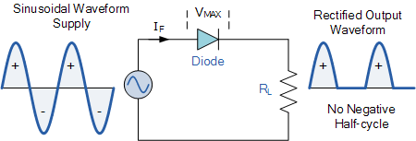

**Full Wave Rectifier:**

Only the current flows through the p-n junction diode and the output current across the load is determined when the diode is in forward bias.

If two diodes are coupled so that one diode conducts during one half of the input voltage cycle and the second diode conducts during the other half of the cycle, a unidirectional current can flow through the load over the whole cycle of the impact voltage.

This is referred to as a full wave rectifier.

The circuit diagram of the full wave diode rectifier given below,

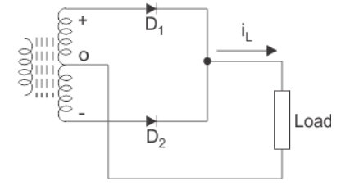

A bridge rectifier comprised of four diodes can also be used to produce full wave rectification.

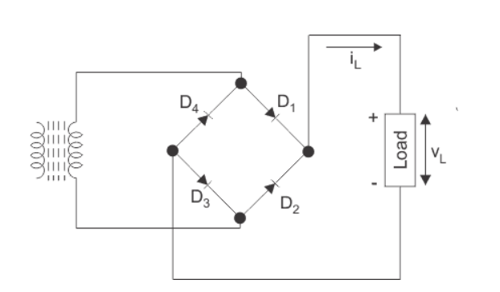

Input voltage and output waveform is:

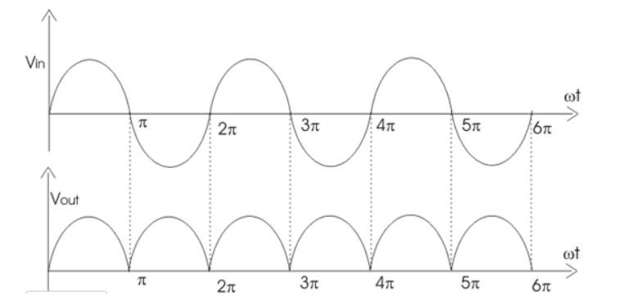

**Experiment Procedure:**

**Half Wave Rectifier:**

* Connect the circuit given.
* Observe the Wave.

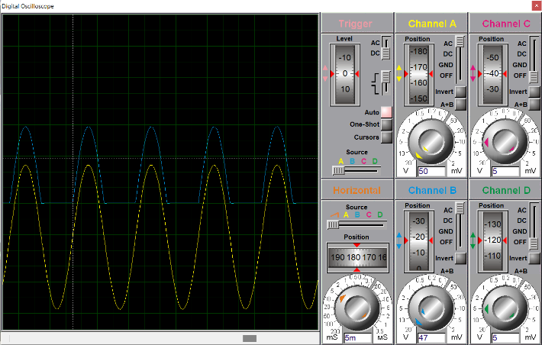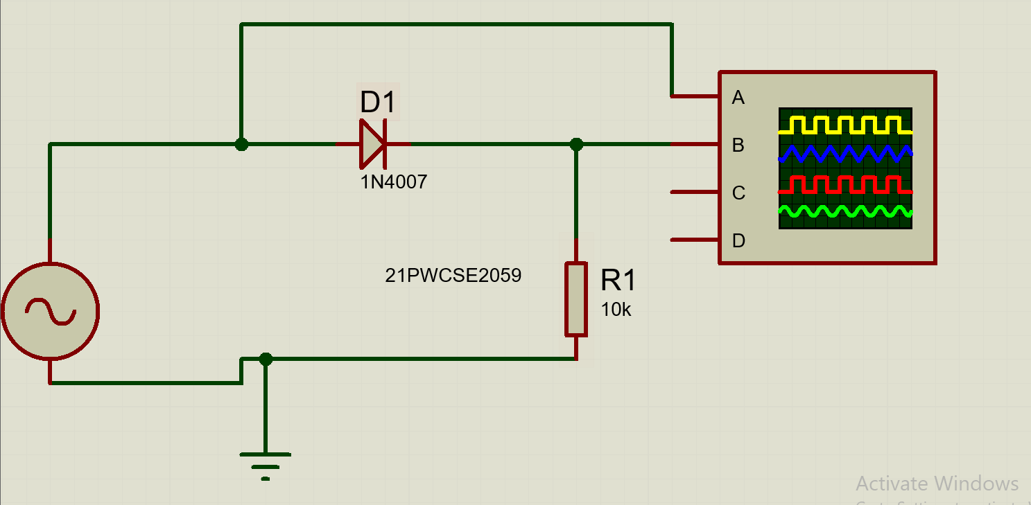

Figure 1-1: Schematic Diagram of Half Wave

Rectifier Circuit in Proteus

Figure 1-2: Output of Half Wave Rectifier Circuit in Proteus

Vsource=0.45V

VClipped = 0.235 V

**Full Wave Rectifier:**

* Connect the circuit given.
* 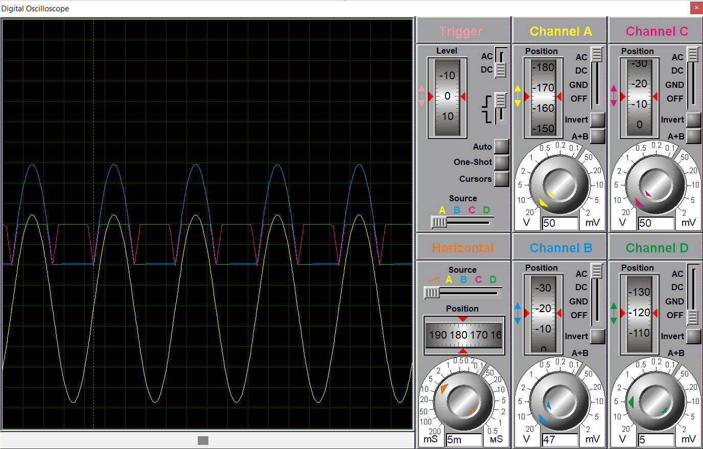Observe the Wave.

Figure 1-4: Output of Full Wave

Bridge Rectifier Circuit in Proteus

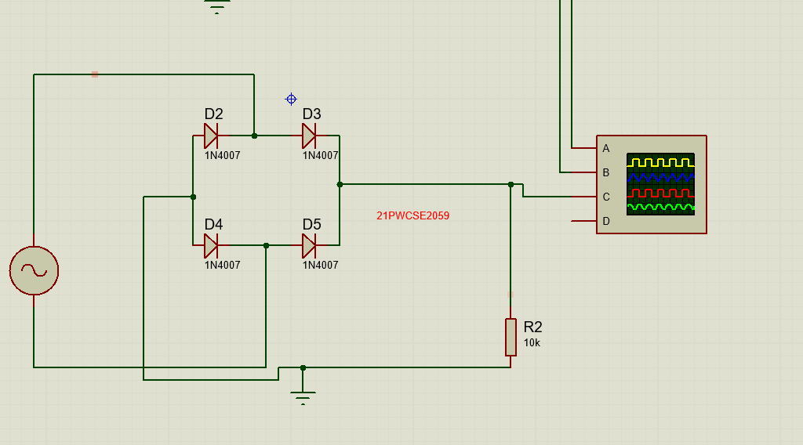

Figure 1-3: Schematic Diagram of Full Wave

Bridge Rectifier Circuit in Proteus

Vsource=0.45V

VClipped = 0.235 V

Vf.w clipped = 0.1V

**PCB Design in Proteus:**

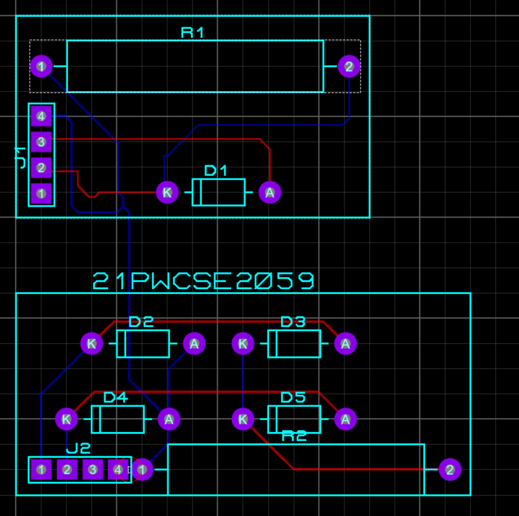

Figure 2-2: 3D View of Half and Full Wave

Rectifier Circuit in Proteus

Figure 2-1: 2D View of PCB of Half and Full Wave

Rectifier Circuit in Proteus

**Practical Circuit Design in Lab:**

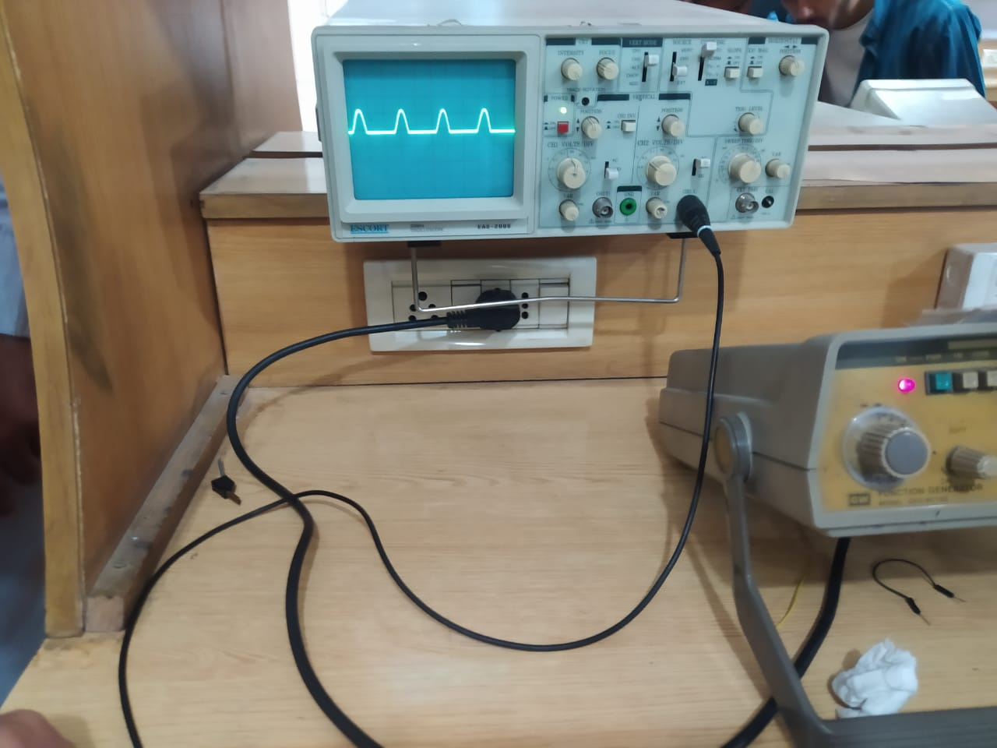

Figure 3-1: Output of Half Wave Rectifier Circuit in Oscilloscope

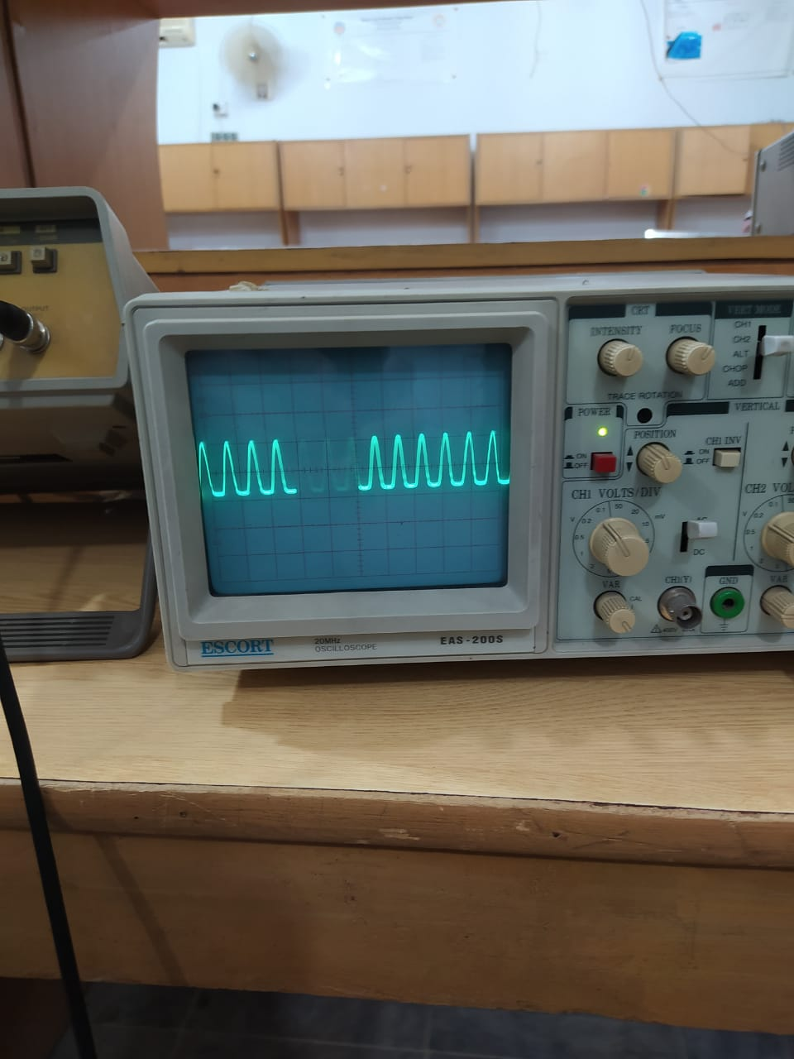

Figure 3-2: Output of Full Wave Bridge Rectifier Circuit in Oscilloscope